Emigrant Letters of
Commendation
Pima-Maricopa Irrigation Project Education Initiative
2003-2004

Restoring water to ensure the
continuity of the Akimel O’otham
and Pee Posh tradition of agriculture

Re

With the Gila and Southern trails entering the Pima villages above the Maricopa settlements, the Pima had an advantage over the Maricopa in demonstrating hospitality. This was done by groups of young Pima men searching for emigrants scattered across the desert or by riders rounding up stray emigrant animals. As thirsty or delirious emigrants came down the Southern Trail from Tucson, many were disoriented, suffered from heatstroke or were separated from their company. While the Pima assisted these emigrants back to their villages to rest, they also frequently rounded up stray animals, restored their health and sold them back to the emigrants.
Part 55

An emigrant named William Chamberlin, for instance, recorded meeting two Pima men out in the desert looking for “horses and mules to exchange with the American emigrants.” Harris observed the two Pima men rounding up “Broken down or abandoned stock” and bringing them to the villages. When emigrant H.M.T. Powell lost one of his horses in the desert, a young Pima man rode twenty-five miles to the south searching for it, returning two days later with the horse. Antonio Culo Azul then encouraged the emigrant to pay $2.00 to the young Pima man for his services. Having only $1.50 on his person, Powell—accompanied by Azul—rode fifteen miles to the emigrant camp to collect the remainder of the fee. The chief then requested a shirt from Powell for his part in the matter. Not willing to accept any shirt, Azul demanded—and received—the shirt then worn by Powell.

Hospitality was also demonstrated by permitting emigrants to graze their stock on the limited grasslands near the Pima and Maricopa villages. An emigrant named Doc Candee visited the villages in August of 1849 and explained how his party remained among the Pima “several days for the purpose of recruiting our stock.” Isaac Duval and a party of Texas Argonauts spent thirteen days at the Pima villages, with one group of weary Texans remaining in the villages for five weeks and purchasing all their food and forage from the Indians.

When emigrant parties arrived at the villages, they were frequently encouraged by the Pima to “dispense with the custody of [their] horses” to be “grazed and herded at good pasture at a distance of two or three miles” from the villages. While there was little forage available enroute to the villages and a limited amount near the villages along the river, grasslands did exist in several locations away from the main road along ephemeral water channels. These grasslands restored many an animal, as noted by Special Indian Agent Sylvester Mowry in a letter to Commissioner of Indian Affairs James W. Denver in September 1857. Pima generosity and service to American citizens, Mowry added, “supplied many a starved emigrant, and restored his broken down animals.”

As Head Pima Chief, Antonio Culo Azul was justly proud of his people’s reputation among the emigrants as shown by his display of their letters of commendation. Although none of these letters is known to have survived, a number of them are referenced in journals of the forty-niners and soldiers. Soldier Cave Couts records Azul showed “passports,” or letters of commendation from a host of emigrants, including Stephen Austin Kearny, Captain A. R. Johnston and a Frenchman “who said that he met the old fellow when in a state of starvation having made his escape from the wild Apaches. Having lost all he had,” the Frenchman continued, Azul “gave him a horse and gun and everything he had that would be of any service to him.”

Another emigrant named Benjamin Hayes wrote Azul showed him “an imposing array of certificates of good behavior from emigrants.” The New York Free Mill Party, for instance, passed through the Pima villages in October and commended the chief for “the Pimos being very friendly & accommodating.” A traveler from Tennessee applauded the Pima’s “kindness and courtesy.” The Fremont Association of New York left a letter extolling the kind treatment received from the Pima.

John Audubon, the son of the famous naturalist of the same name, wrote that Azul—as was apparently his custom—came out to meet the emigrants and presented them with an array of letters “recommending him as honest, kind and solicitous for the welfare of Americans.” Benjamin Harris added Azul “showed us many written testimonials, principally of trappers, attesting his kindness to them, even to remounting, rearming and revictualizing them.” Not all testimonials were noteworthy. One, written by Philip St. George Cooke regarding an unnamed Pima man, stated, “This fellow is a d---d Rascal. Look out for him. Lt. Cook, USA.”

Inclined to generosity and charity, the Pima and Maricopa expected the emigrants to engage in gift exchange or, as Couts observed in 1848, “they would think hard of it.” But the Indians also knew they were highly venerated and well thought of. As a result, the 6’4” dignified and stately Azul expected a certain level of respect. Without the necessary regards, emigrants might experience price hikes for goods they wished to purchase or acquire, increased charges for services such as rounding up stray stock, or even loss of personal possessions.

Powell, for example, came through the Pima villages in October 1849 as part of an emigrant train under the leadership of a man named Captain White. Azul, dressed in full military regalia, came out to meet the captain as the emigrants approached. White, however, offended the aged chief by failing to exchange pleasantries and gifts. Such “cavalier treatment” bore just results. When the emigrants later sought to purchase food from the Indians they found the Pima “difficult to trade with.” The situation soon worsened when the Indians “stole a great quantity of things from us,” including axes, hatchets, pistols, blankets and coats. Powell attributed such theft to White’s poor treatment and the inattention to protocol. If the captain had “made the old chief some presents,” Powell penned in his journal, “and paid his compliments to him in a proper way it would not have happened.” Inattention to protocol could greatly impact the successful trade and social intercourse between the Pima and the emigrants.

Grasslands along Central Arizona Waterways
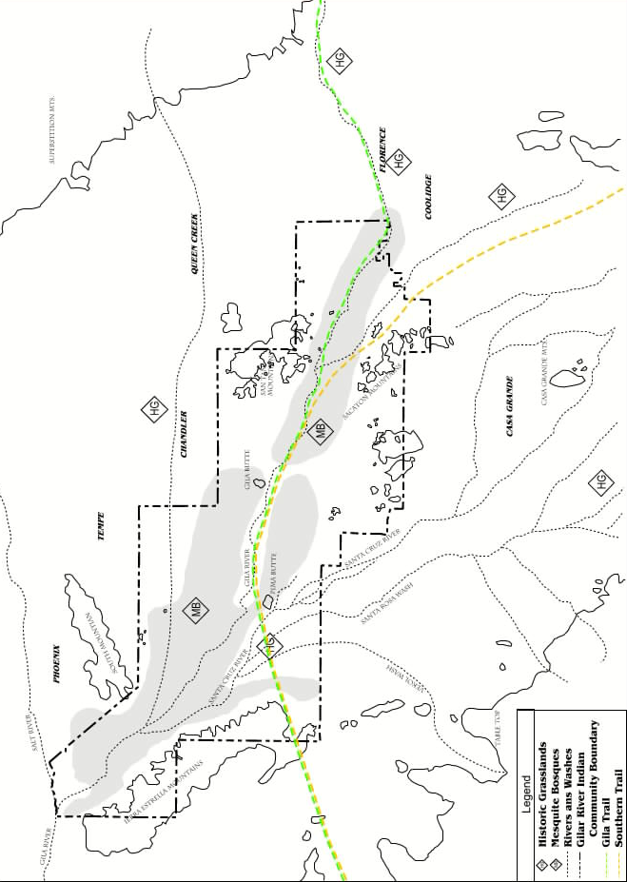
Teacher Plan for “Emigrant Letters of Commendation”
Objectives

Students will be able to:

- Describe Pima and Maricopa agricultural fields and crops they produced.

- Explain ways Pima and Maricopa agriculture was changing in the mid 19th century.
Terms to know and understand

- Delirious
- Ephemeral
- Cavalier
- Venerated
- Solicitous
- Protocol
Critical Thinking:

- The Pima and Maricopa were always known for their friendship and hospitality. Why were they so friendly? For what possible reason would the people ride out into the desert in search of lost, tired and thirsty emigrants and their animals? And if grass were in short supply, why would the Pima and Maricopa allow the emigrants to graze their horses and mules on these lands? Could it be said the Pima and Maricopa in the emigrant years provided services to passerbyers? Is the Gila River Indian Community doing this today? Explain.
Activities:

- Remind students that the word “recruit” was commonly used in the 19th century to mean “allowing people and animals to rest and regain their strength” rather than its modern meaning of “enlisting members to join up.” While most emigrants stayed only a day or two in the villages, some stayed longer. Some Texas Argonauts stayed five weeks. If you had travelers stay in your village for a week or two (or five!) what would you do differently? Remember, there was no Phoenix, Mesa, Chandler or Casa Grande to visit to view a movie or visit a skating park.
- Many emigrants left letters of commendation praising the Pima and Maricopa. Military groups issued some of these in 1846 directing emigrants to respect the authority and rights of the Pima and Maricopa, while emigrants wrote more. If someone were to write a letter about you what would they say? What would you want them to say? If these two descriptions don’t match, how come?
- When H.M.T. Powell visited the Pima villages in October 1849, his group offended chief Azul by not following protocol. This means they did not do what was expected of them by showing respect for the chief and the community as a whole. Does this still happen today? How can you “fix” it?
About P-MIP

The Pima-Maricopa Irrigation Project is authorized by the Gila River Indian Community to construct all irrigation systems for the Community. When fully completed, P-MIP will provide irrigation for up to 146,330 acres of farmland. P-MIP is dedicated to three long-range goals:
- Restoring water to the Akimel O’otham and Pee Posh.
- Putting Akimel O’otham and Pee Posh rights to the use of water to beneficial use.
- Demonstrating and exercising sound management to ensure continuity of the Community’s traditional economy of agriculture.

